

**Mate Crime**

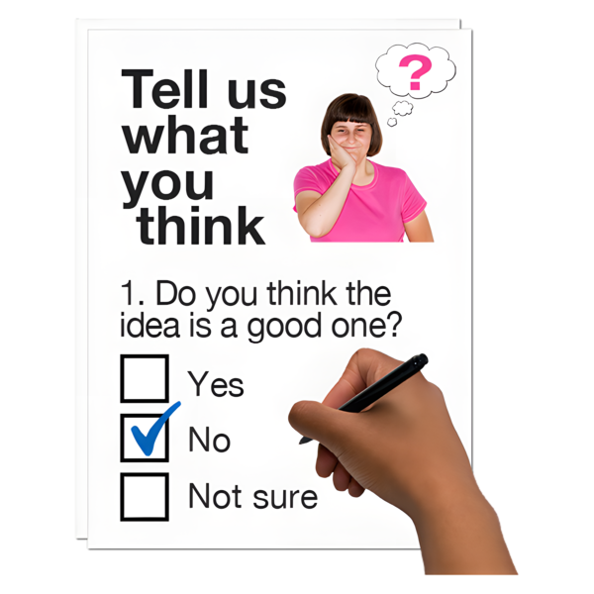



**This is an easy to read survey**

**Question 1**

**Which of the following best describes you?**

**Select all that apply**

|  |  |  |
| --- | --- | --- |
| **\\files\home$\GalwayAdvocacy\Downloads\Who.png** | I am a disabled person |  |
| \\files\home$\GalwayAdvocacy\Downloads\Staff Team Support.png\\files\home$\GalwayAdvocacy\Downloads\Teens 3.png | I work for a disability service provider |  |
| \\files\home$\GalwayAdvocacy\Downloads\Group 43 (1).png | I work for a Disabled Persons Organisation (DPO) or Non-Governmental Organisation (NGO) |  |
| \\files\home$\GalwayAdvocacy\Downloads\Police interview 1.png | I work in the justice system for example Gardaí or other justice agency |  |
|  | I am a researcher, policymaker, or legal professional |  |
| \\files\home$\GalwayAdvocacy\Downloads\Mother Daughter 2.png\\files\home$\GalwayAdvocacy\Downloads\Researcher 1.png | I am a family member or provide support for a disabled person |  |

    ]

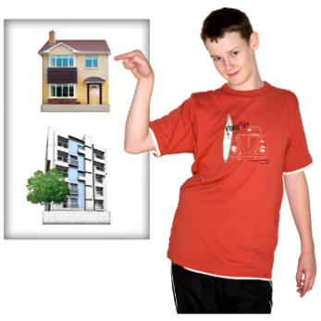 **Question 2. Where do you live?**

|  |  |  |
| --- | --- | --- |
| **\\files\home$\GalwayAdvocacy\Downloads\City 2.png** | Urban area that is a town or city |  |
| **\\files\home$\GalwayAdvocacy\Downloads\Community.png** | Suburban area |  |
| **\\files\home$\GalwayAdvocacy\Downloads\Nuclear Power Station 1.png** | Rural area |  |

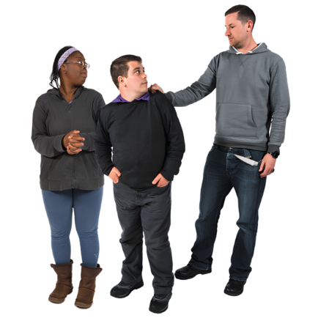 **Question 3.**

**Have you heard of the term “mate crime” before?**

|  |  |  |
| --- | --- | --- |
| **\\files\home$\GalwayAdvocacy\Downloads\Tick Yes.png** | Yes |  |
| **\\files\home$\GalwayAdvocacy\Downloads\Cross No.png** | No |  |
|  | Don’t know |  |

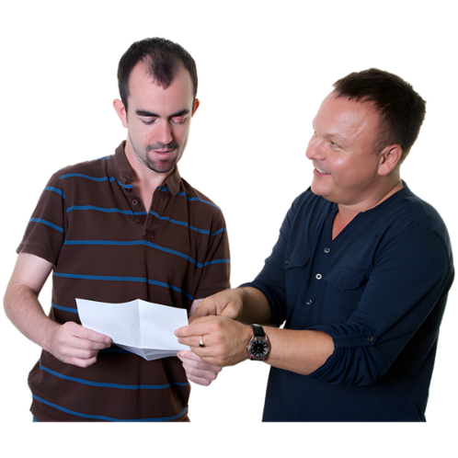**Question 4.**

**In your own words, what do you think the term ‘mate crime’ means?**

__________________________________________________

__________________________________________________

__________________________________________________

__________________________________________________

__________________________________________________

__________________________________________________

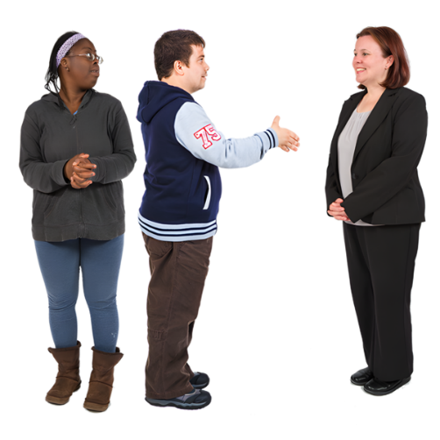

5.**Have you ever personally experienced or witnessed crime or abuse against a disabled person that you believe may have been due to their disability?**

|  |  |  |
| --- | --- | --- |
|  | Yes |  |
|  | No |  |

6. **If yes what type of crime or abuse did you experience or witness? (Select all that apply)**

|  |  |  |
| --- | --- | --- |
| \\files\home$\GalwayAdvocacy\Downloads\Cash Hand Euros (1).png | Financial exploitation |  |
| \\files\home$\GalwayAdvocacy\Downloads\Winterbourne abuse 11.png | Physical abuse |  |
| \\files\home$\GalwayAdvocacy\Downloads\Gossip 2.png | Emotional or psychological abuse |  |
| \\files\home$\GalwayAdvocacy\Downloads\Senior confused.png | Manipulation or coercive control |  |
| \\files\home$\GalwayAdvocacy\Downloads\Sexual harassment.png | Sexual exploitation |  |
| \\files\home$\GalwayAdvocacy\Downloads\Facebook.png | Online abuse or scams |  |



7. **Please feel free to tell us more about the crime or abuse you experienced or witnessed here.**

__________________________________________________

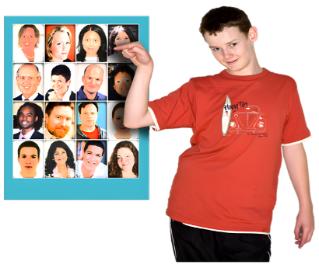 8. **Based on your experience, who are the people that have carried out mate crime? (Select all that apply)**

|  |  |  |
| --- | --- | --- |
| \\files\home$\GalwayAdvocacy\Downloads\Talk Over You 4.png | Support workers or carers |  |
| \\files\home$\GalwayAdvocacy\Downloads\Community Nurse (1).png | Neighbours |  |
| \\files\home$\GalwayAdvocacy\Downloads\Group 2.png | Other people who use disability services |  |
| \\files\home$\GalwayAdvocacy\Downloads\Community (1).png | Acquaintances, for example someone known from the community or social settings |  |
| \\files\home$\GalwayAdvocacy\Downloads\Friends celebrate2.png | Friends or people pretending to be friends |  |
| \\files\home$\GalwayAdvocacy\Downloads\Couple hug2.png | Romantic or sexual partners |  |
| \\files\home$\GalwayAdvocacy\Downloads\Dont let strangers.png | Strangers |  |
| \\files\home$\GalwayAdvocacy\Downloads\Household 3.png | Family members |  |

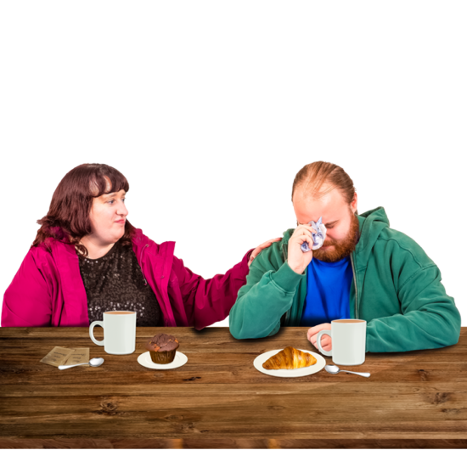

9. **How did the experience of mate crime affect you or the person you supported?**

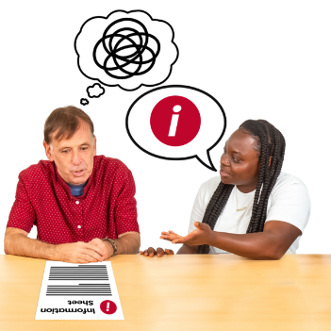10. **Do you feel you or the person you support had enough information to recognise that what happened was a crime or abuse?**

|  |  |  |
| --- | --- | --- |
|  | Yes |  |
|  | No |  |
|  | Don’t know |  |

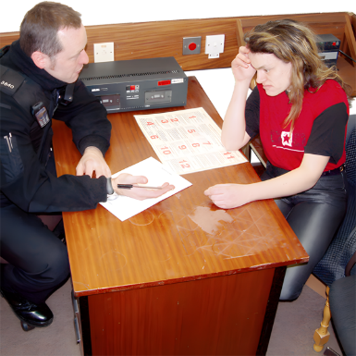

11. **Was this experience reported to the Gardaí?**

|  |  |  |
| --- | --- | --- |
|  | Yes |  |
|  | No |  |

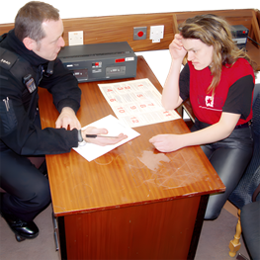****12. **If the experience was not reported, what do you think stopped you, or the person affected, from reporting it? (Select all that apply)**

|  |  |  |
| --- | --- | --- |
| \\files\home$\GalwayAdvocacy\Downloads\Carer Picks On Man 1.png | Fear of not being believed |  |
| \\files\home$\GalwayAdvocacy\Downloads\Threatening carer.png | Fear of retaliation |  |
| \\files\home$\GalwayAdvocacy\Downloads\Statement1.png | Lack of trust in Gardaí |  |
| \\files\home$\GalwayAdvocacy\Downloads\Freedom Blocked.png | Lack of trust in support services |  |
| \\files\home$\GalwayAdvocacy\Downloads\Who (1).png | Did not know where to seek help |  |
| \\files\home$\GalwayAdvocacy\Downloads\Form Easy vs Jargon.png | Lack of accessible reporting options |  |



13. **Is there anything else you would like to share about why people might not report crime or abuse?**

__________________________________________________

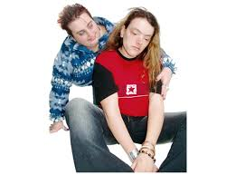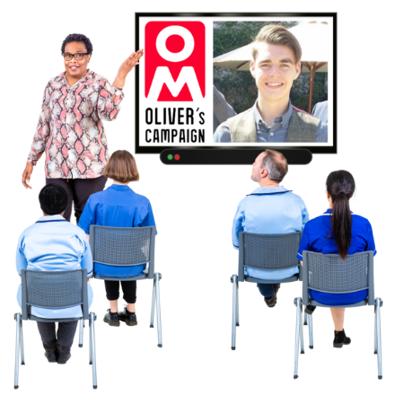14. **How would you describe the awareness of mate crime among Gardaí?**

|  |  |  |
| --- | --- | --- |
| \\files\home$\GalwayAdvocacy\Downloads\Thumbs up 3.png | **High**  Gardaí understand mate crime and respond appropriately |  |
| \\files\home$\GalwayAdvocacy\Downloads\Improve.png | **Moderate**  Some awareness but responses vary |  |
| \\files\home$\GalwayAdvocacy\Downloads\Thumbs down.png | **Low**  Limited awareness and inconsistent responses |  |

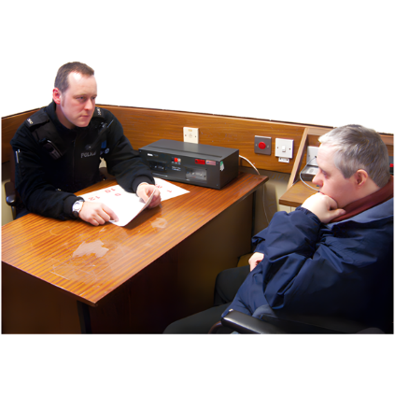15. **Have you or your organisation worked with Gardaí on cases related to mate crime?**

|  |  |  |
| --- | --- | --- |
|  | Yes |  |
|  | No |  |

16. **Is there anything you would like to share about how Gardaí or other justice services respond to mate crime?**

__________________________________________________

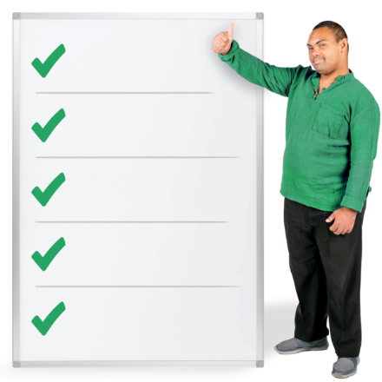17. **Have you seen any examples of good practice or positive responses from Gardaí or services?**

18. **Do you believe Gardaí receive adequate training on disability awareness and mate crime?**

|  |  |  |
| --- | --- | --- |
|  | Yes |  |
|  | No |  |
|  | Don’t Know |  |

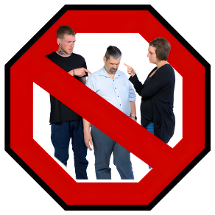

19. **What barriers prevent disabled people from seeking help or justice? (Select all that apply)**

|  |  |  |
| --- | --- | --- |
| \\files\home$\GalwayAdvocacy\Downloads\Confused 5.png | Lack of awareness about what counts as a crime |  |
| \\files\home$\GalwayAdvocacy\Downloads\Ignored.png | Gardaí or other services not taking concerns seriously |  |
| \\files\home$\GalwayAdvocacy\Downloads\Not Talking 1.png | Fear of losing the relationship |  |
| \\files\home$\GalwayAdvocacy\Downloads\Form Easy vs Jargon.png | Lack of accessible reporting systems |  |
| \\files\home$\GalwayAdvocacy\Downloads\Alone 1.png | Fear of losing independence or support if reported |  |
|  | Fear of not being believed |  |
| \\files\home$\GalwayAdvocacy\Downloads\Confidential (2).png | Concerns about confidentiality or being recognised |  |

20. **Do you think it would be helpful to legally recognise mate crime as a specific criminal offence?**

|  |  |  |
| --- | --- | --- |
|  | Yes |  |
|  | No |  |
|  | Don’t know |  |

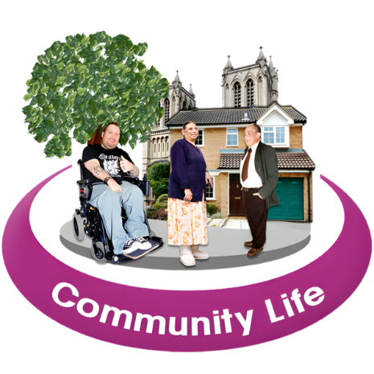

21. **Do you think the risk of mate crime affects how disabled people live independently and take part in the community? If yes, how?**

__________________________________________________

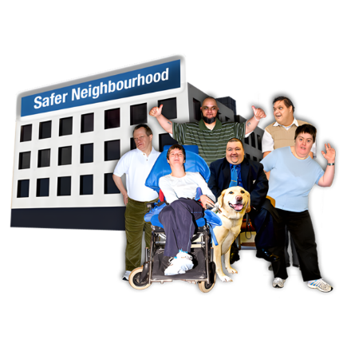 22. **What improvements would you like to see in policing and community safety?**

__________________________________________________

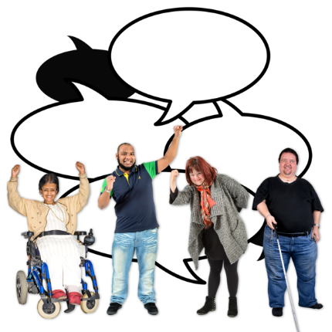

23. **What improvements would you like to see in Disability services and advocacy?**

__________________________________________________

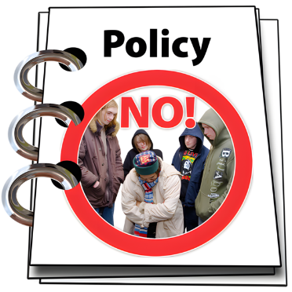24. **What legal or policy changes would most help prevent mate crime or support those affected?**

__________________________________________________

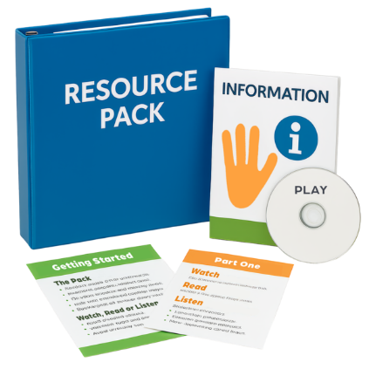25. **What kind of support, training, or resources would help prevent mate crime? (Select all that apply)**

|  |  |  |
| --- | --- | --- |
| C:\Users\GalwayAdvocacy\AppData\Local\Microsoft\Windows\INetCache\Content.MSO\755DCAD5.tmp | Public awareness campaigns about mate crime |  |
| \\files\home$\GalwayAdvocacy\Downloads\Flipchart 9.png | Relationship and boundaries education |  |
| \\files\home$\GalwayAdvocacy\Downloads\Moneybag Euros.png | Greater funding for advocacy and self-advocacy organisations |  |
| \\files\home$\GalwayAdvocacy\Downloads\Group 77.png | Peer led programmes or workshops |  |
| \\files\home$\GalwayAdvocacy\Downloads\Check Easy Read 1 (1).png | Clear, accessible information about rights and how to report abuse |  |
| \\files\home$\GalwayAdvocacy\Downloads\Co-Training 1.png | Disability awareness and safeguarding training for Gardaí and justice professionals |  |
| \\files\home$\GalwayAdvocacy\Downloads\Stop Abuse Sign.png | Training for support workers and family members to recognise signs of abuse |  |
| \\files\home$\GalwayAdvocacy\Downloads\Conditions Met.png | Stronger vetting and oversight of support staff |  |

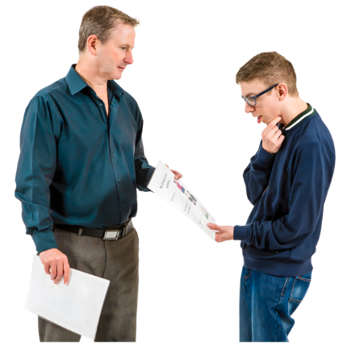

26. **Is there anything else you would like to share about mate crime or targeted abuse against disabled people?**